Node-red flow link:

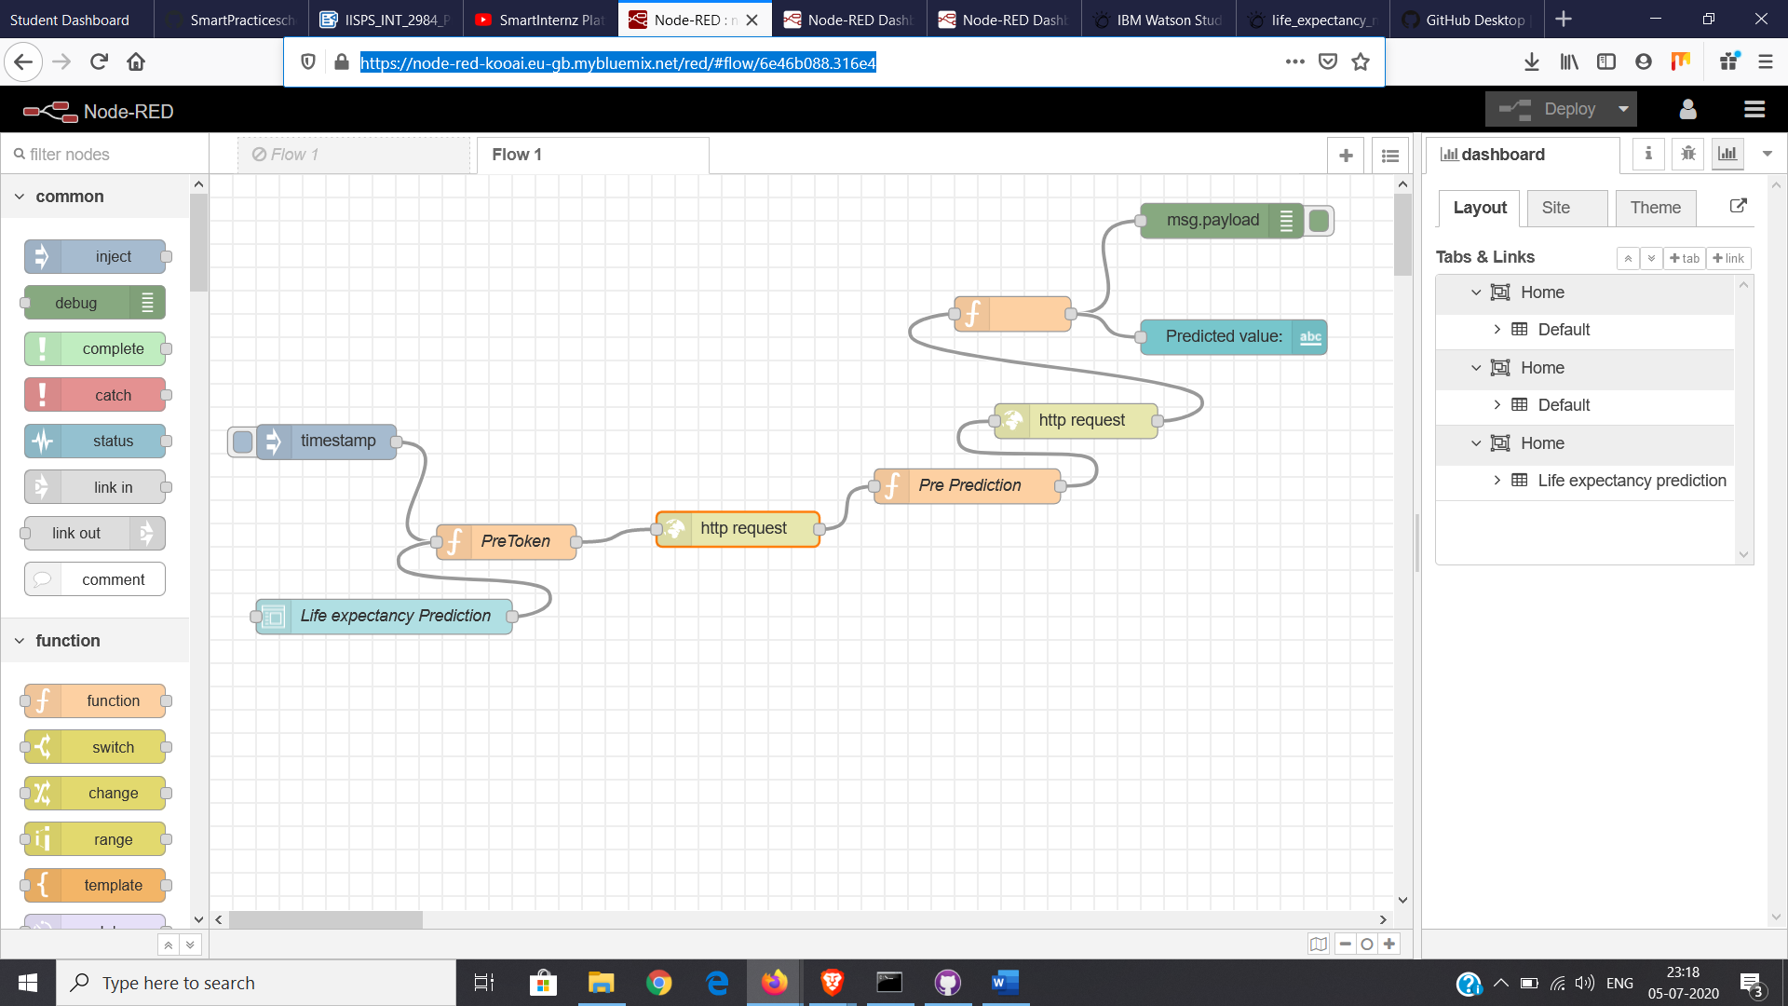<https://node-red-kooai.eu-gb.mybluemix.net/red/#flow/6e46b088.316e4>

OUTPUT link:

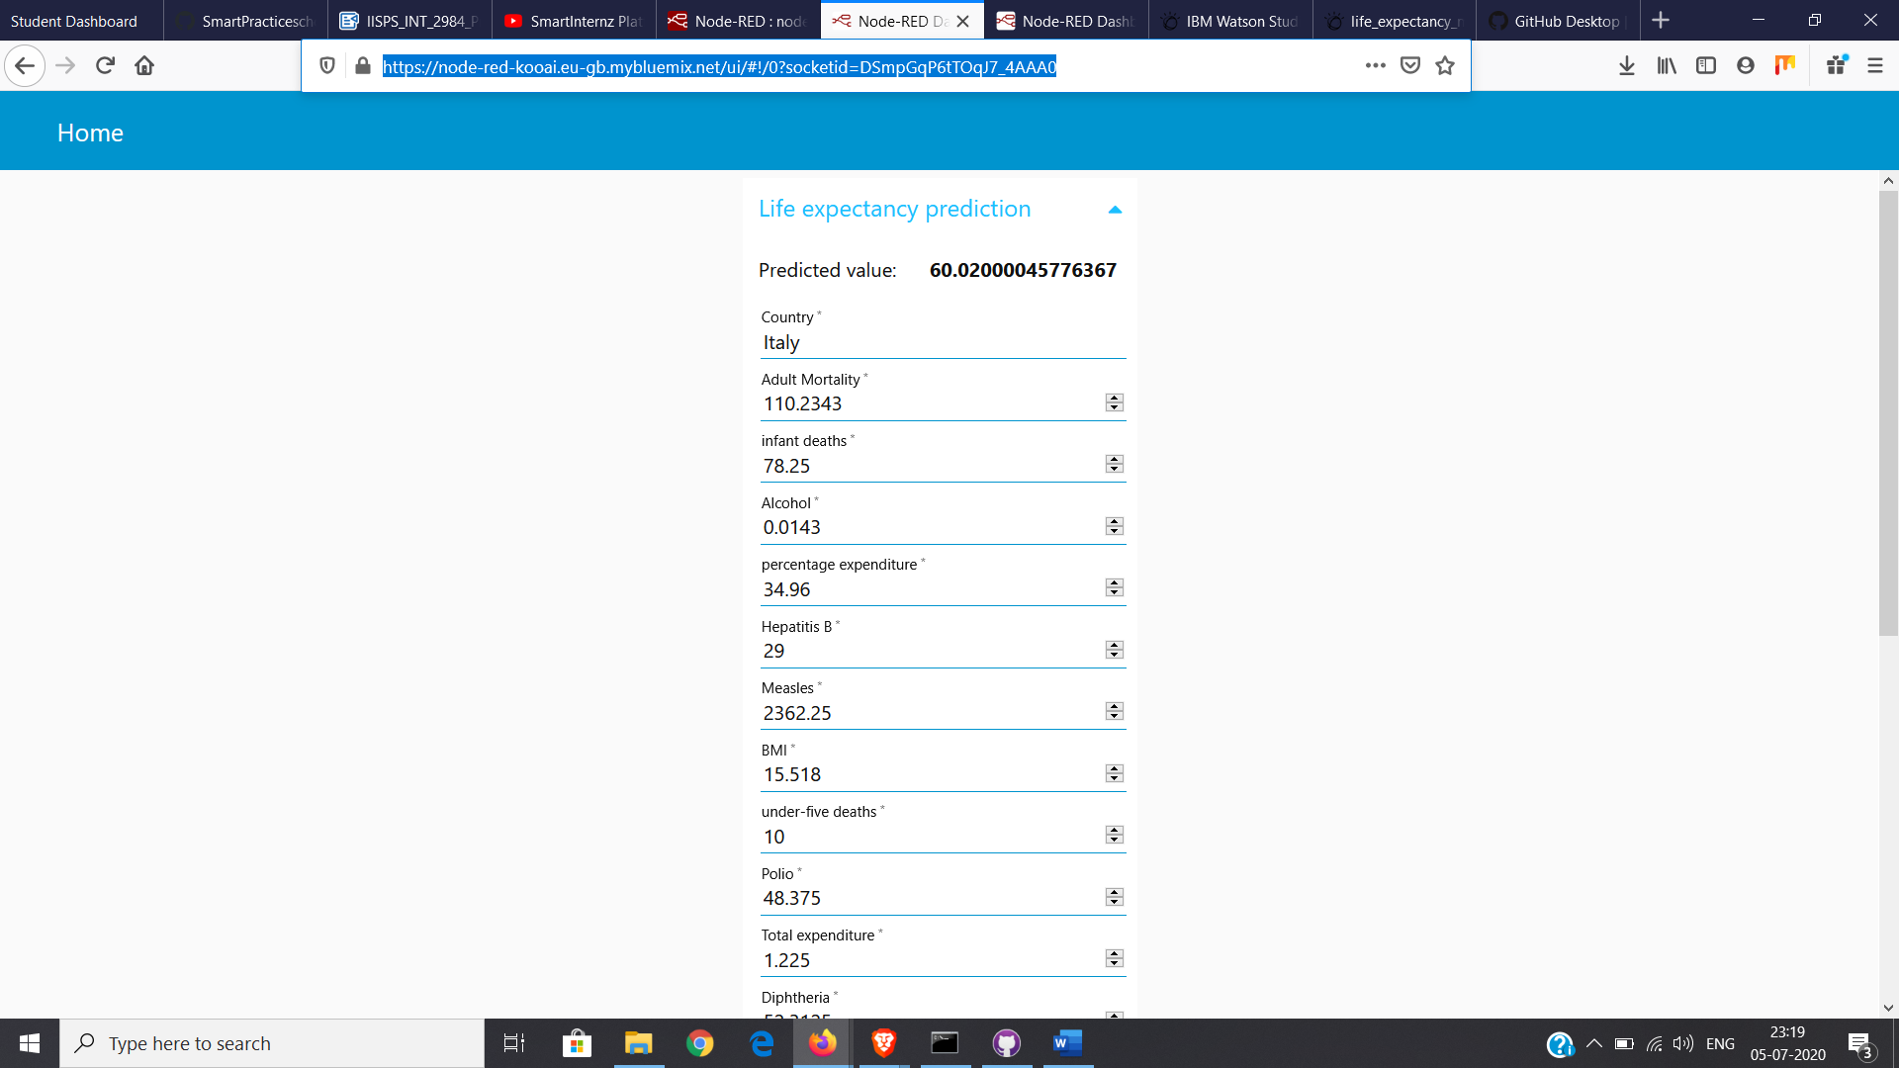<https://node-red-kooai.eu-gb.mybluemix.net/ui/#!/0?socketid=DSmpGqP6tTOqJ7_4AAA0>